# **Lab 5.3 Exploring Player Dialogue Choices**

**Load up Glyph**

Please go to the following link: <https://truonghuy.github.io/glyph-vpal-dialogue/>. This loads up VPAL dialogue data. You already have seen VPAL data in earlier chapter. The data used in this visualization is just the dialog part of one of the levels. You can start interacting with the interface to familiarize yourself with it.

Note that the **State** graph is to the left and the **Sequence** graph is to the right. Green nodes in the sequence graph represent sequences that completed the given quest, pink nodes are ones did not.

**Interacting with Glyph**

You can interact by selecting nodes in the *sequence* graph to see what pattern gets highlighted. As the pattern gets highlighted, you can move nodes around in the state graph to see the sequence more clearly. You can also inspect the dialogue represented by the states and transitions via the pop-ups that appear to the right and upper-left sides of the screen as you highlight different parts of the visualization.

Try clicking on different nodes on the *sequence* graph and see how the *state* graph reacts and dialogue patterns change.

**Highlighting two (or more) different sequences**

To compare different sequences, you can highlight different nodes in the *sequence* graph. In particular, click on two nodes that are very different, then make sure you remember their numbers.

Then go to the text field right next to the text: Enter more or many sequence indices to highlight, on the upper right. Enter the two (or more) numbers with semi-colons separated as shown in the figure below. Then click highlight. This will cause glyph to highlight the two nodes so you can inspect their differences. See figure below.

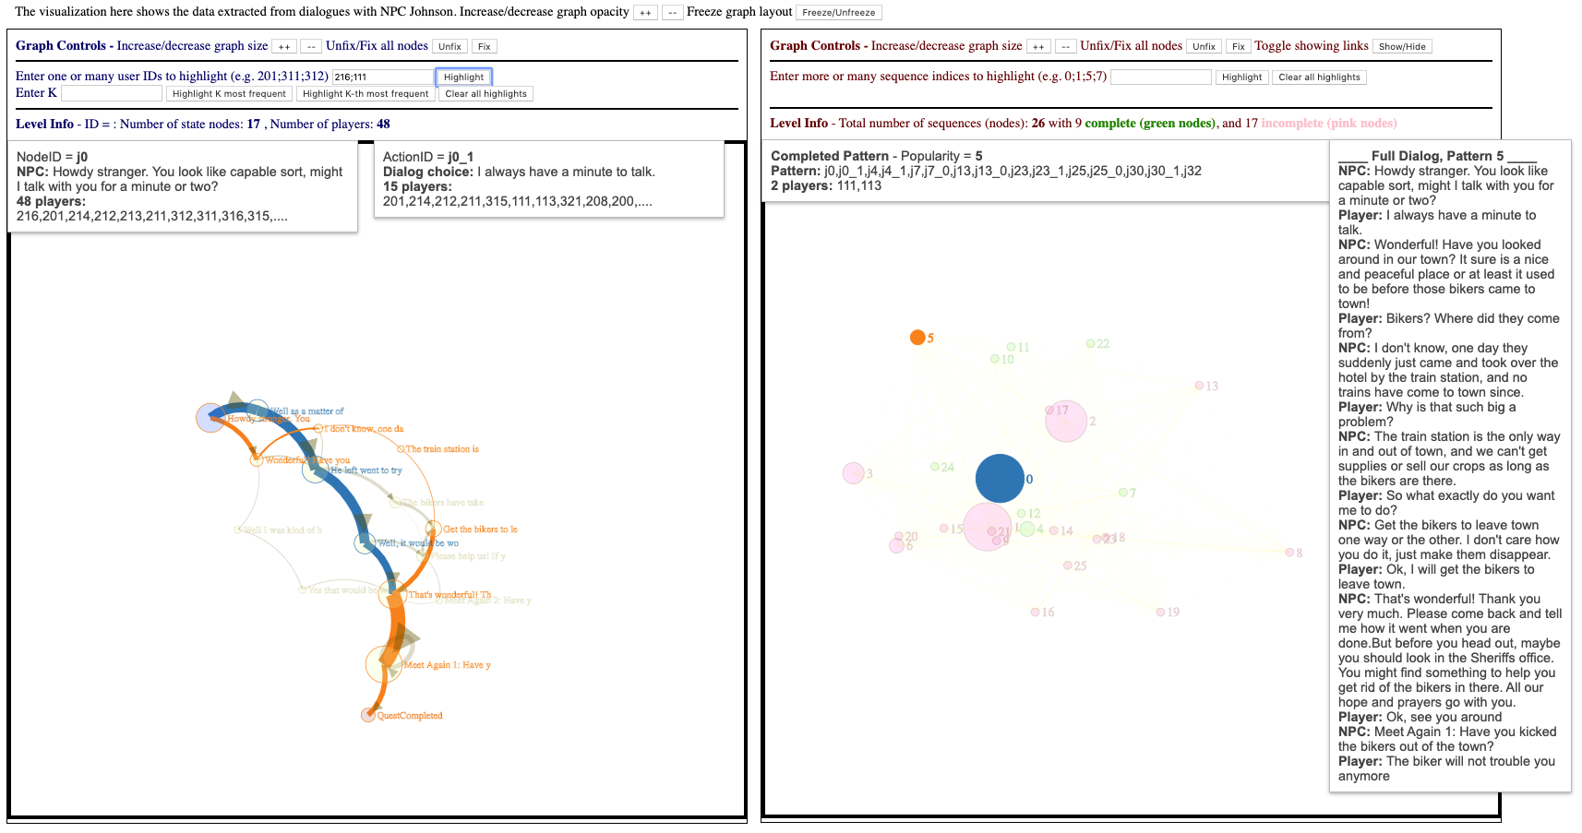

You can continue to play around to highlight different players with divergent gameplay.

In the chapter, we demonstrated an exploratory analysis of the two patterns highlighted above. Pattern 0, one of the most popular, represents players who followed a direct line of conversation straight to the acceptance of the quest. Pattern 5 represents players who asked questions about the nature of the world around them, such as “where did the bikers come from?” before accepting the quest. This indicates two different player types: those who wish to get right to the point, and those who wish to obtain more narrative context about what they are experiencing and being asked to do.

In conclusion, in the lab, we went through an example of using *Glyph*, the visualization system introduced in Chapter 5 to visualize and analyze dialog data from VPAL. As you can see, using such visualization system is very powerful in exposing differences and similarities in play behaviors. You can take this opportunity to play around with the controls in *Glyph* and see if you can identify any other varied sequence patterns. Then try to develop some conclusions about what they mean.